ZSA-406 Online Turbidity Sensor
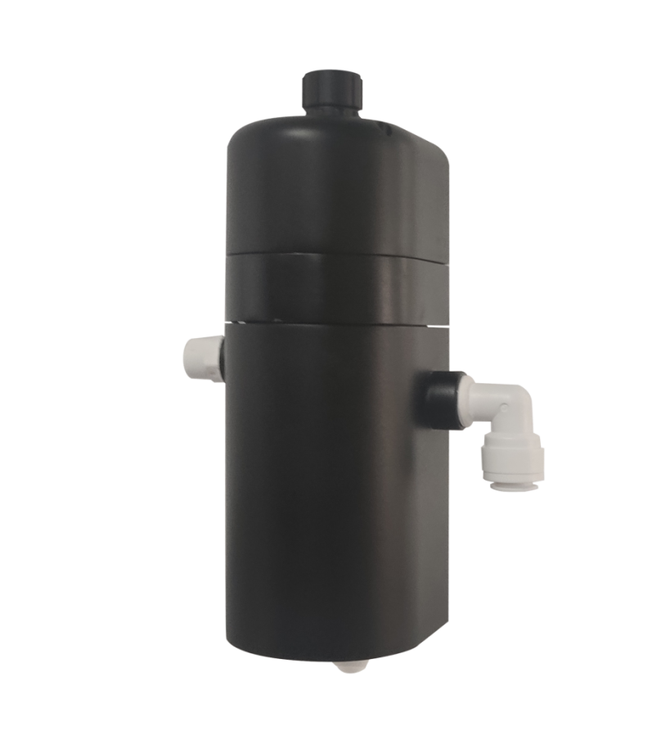

Hangzhou Chemins Tech Co., Ltd.
Yantai Chemins Instrument Co., Ltd.
Tel：0535-3463801/89870583
E-mail：service@chemins-tech.com ; info@chemins-tech.com
Website：www.chemins-tech.com
Address: Room 902, Building 19, No. 260, 6th Street, Baiyang Street, Qiantang District, Hangzhou, China (Zhejiang) Pilot Free Trade Zone
10 Ankang Nan Lu, Zhaoyuan Economic and Technological Development Zone, Yantai City, Shandong Province, China
User Notes

- Before use please read this description, and save it for reference.
- Please follow this manual procedures and precautions.
- Upon receipt of the instrument, carefully open the package, whether viewing instruments and accessories due to shipping damage, if any damage is found, immediately notify the manufacturers and distributors, and retain the packaging material for return processing.
- When the instrument malfunction, do not repair itself, please contact the manufacturer's after-sales department.

contents
Ⅰ. Working principle 4
Ⅱ. Technical performance and specifications 4
1. Technical parameters 4
2. Dimensional drawing 5
Ⅲ. Installation and electrical connection 5
1. Installation 5
2. Electrical connection 6
Ⅳ. Maintenance and maintenance 6
Maintenance procedures and methods 6
2. Calibration of sensors 7
3. FAQ 7
Ⅴ. Quality and service 8
1. Quality assurance 8
2. Accessories and spare parts 8
3. After-sales service commitment 8
Appendix Data Communication 9

Ⅰ. Working principle
iZSA-306 flow-through online turbidity sensor is designed and manufactured based on the principle of scattered light turbidity measurement method. When a beam of light is emitted into a water sample, the turbidity substances in the water sample scatter the light. By measuring the scattered light intensity perpendicular to the incident light and comparing it with the internal calibration value, the turbidity in the water sample is calculated. degree, and output the final value after linearization. It can be widely used in online turbidity monitoring of tap water, secondary water supply, municipal pipe network terminal water, direct drinking water, membrane filtered water, swimming pools, etc.
- 90° angle scattered light principle, built-in temperature sensor
- Supports RS-485 (Modbus RTU) protocol, 4-20 mA current output
- Fiber optic structure, strong ability to resist external light interference
- Infrared LED light source, high stability
- Integrated design of sensor flow cell, small size and high integration
- IP65 protection
- Convenient, fast, stable and easy to maintain

Ⅱ. Technical performance and specifications

Technical parameters
model | ZSA-406
Measurement principle | scattered light method
Range and resolution | 0~10.000 NTU | 0.001
Accuracy | ±2% or ±0.02 NTU, whichever is greater; ±0.3℃
Calibration method | Two point calibration
Cleaning method | /
Temperature compensation | Automatic temperature compensation (Pt1000)
output method | RS-485(Modbus RTU)
storage temperature | -5～65℃
working conditions | 0～50℃，≤0.2MPa
shell material | composite materials
Installation method | Wall mounting
Power consumption | 0.2W@12V
powered by | 12～24V DC
Protection level | IP65
pipeline | 2 points/3 points pure water pipe

Dimensional drawing
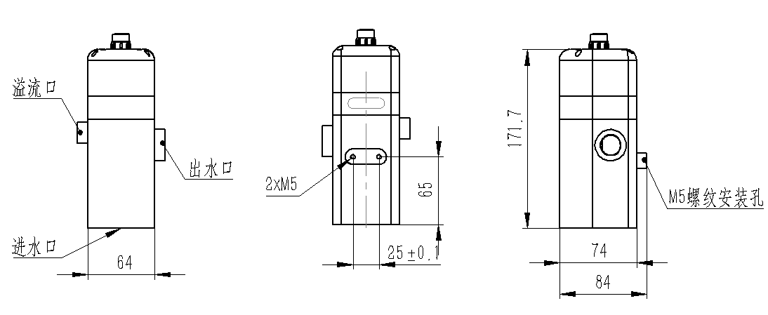
Note: The sensor connector is M16-5 core waterproof connector male

Ⅲ. Installation and electrical connection

Installation
For wall-mounted installation, it is recommended to use it with our pressure reducing flow controller CVC-100. The assembly diagram is as follows; 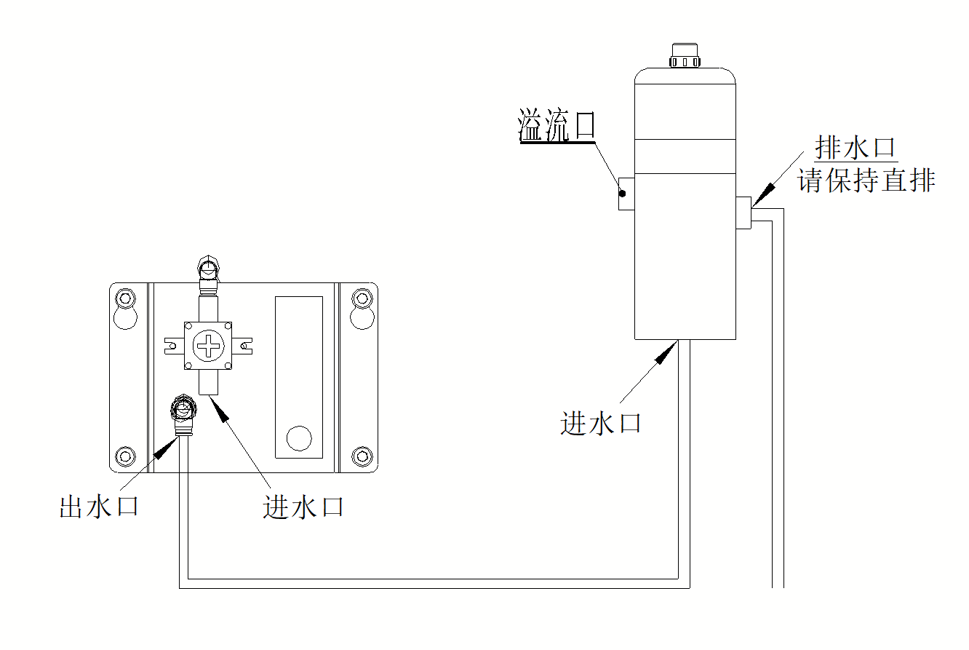
Note: The drain outlet should be kept straight, and the flow rate of the drain pipe is recommended to be <300ml/min to ensure the accuracy of the test.

Electrical connection
The cable is a 5-core shielded wire, and the wire sequence is defined as:
- Red wire—power cord (12~24VDC)
- Black wire—ground wire (GND)
- Blue wire—485A
- White wire—485B
- Yellow wire—current output (if not used, it can be left floating)
The wiring sequence should be carefully checked before powering on to avoid unnecessary losses caused by wiring errors.
Wiring instructions: Considering that cables are immersed in water (including seawater) or exposed to the air for a long time, all wiring locations are required to be waterproofed, and user cables should have certain anti-corrosion capabilities.

Ⅳ. Maintenance and maintenance

Maintenance procedures and methods

1.1maintenance schedule
The cleanliness of the measuring window is very important to maintaining accurate readings.
Maintenance tasks | Recommended maintenance frequency
Calibrate the sensor (if required by the competent authority) | Carry out according to the maintenance schedule required by the competent authority
1.2Maintenance method
- Outer surface of the sensor: Clean the outer surface of the sensor with tap water. If there are still debris remaining, wipe it with a damp soft cloth. For some stubborn dirt, you can add some household detergent to the tap water to clean it.
- Check the sensor cable: The cable should not be tightened during normal operation, otherwise it is easy to break the wires inside the cable and prevent the sensor from working properly.
- Check whether the measurement window of the sensor is dirty and whether the cleaning brush is normal.
1.3Precautions
The sensor contains sensitive optical and electronic components. Make sure the sensor is not subject to severe mechanical impact. There are no user-serviceable parts inside the sensor.

Calibration of sensors
- Zero point calibration: Use a larger beaker to measure an appropriate amount of zero turbidity liquid, place the sensor vertically in the solution, with the measuring end of the sensor at least 10cm away from the bottom of the beaker, and wait for 3 to 5 minutes for the value to stabilize before performing zero point calibration. See the appendix for instructions.
- Slope calibration: Place the sensor measurement end face in the standard solution. The sensor measurement end face is at least 10cm away from the bottom of the beaker. Wait for 3 to 5 minutes for the value to stabilize before performing slope calibration. See the appendix for instructions.

FAQ
question | possible reason | Solution
The operation interface cannot connect or does not display the measurement results. | The measured value is too high, too low or the value continues to be unstable | Reconnect the controller and cables
 | Cable failure | Please contact us
The measured value is too high, too low or the value continues to be unstable | The sensor window is attached to a foreign object | Clean the sensor window surface

Ⅴ. Quality and service

Quality assurance
- The quality inspection department has standardized inspection procedures, advanced and complete testing equipment and means, and strictly follows the inspection procedures. It conducts 72-hour aging tests and stability tests on the products, and does not allow any unqualified products to leave the factory.
- The consignee will directly return batches of products with a defective rate of 2%, and all costs incurred will be borne by the supplier. For testing standards, refer to the product description provided by the supplier.
- Ensure supply quantity and shipping speed.

Accessories and spare parts
This product includes:
- 1 sensor
- 1 copy of instruction manual
- 1 certificate of conformity
- 1 cable (5 meters)

After-sales service commitment
Our company provides after-sales service for this machine within one year from the date of sale, but does not include damage caused by improper use. If repair or adjustment is required, please send it back, but the freight will be borne by you. When sending it back, make sure it is well packaged to avoid shipping. If the instrument is damaged during the journey, our company will repair the damage to the instrument free of charge.

Appendix Data Communication

- Data format
The default data format of Modbus communication is: 9600, n, 8, 1 (baud rate 9600bps, 1 start bit, 8 data bits, no parity, 1 stop bit).
- Information frame format (xx represents one byte)
- Read data command frame
07 03 xx xx xx xx xx xx
address function code Register starting address Number of registers CRC check code (low byte first)
b) Read data response frame
07 03 xx xx……xx xx xx
address function code Number of bytes response data CRC check code (low byte first)
- Write data command frame
07 06 xx xx xx xx xx xx
address function code Register address data input CRC check code (low byte first)
- b) Read data response frame (Same as write data command frame)
07 06 xxxx xx xx xx xx
address function code Register address data input CRC check code (low byte first)
- Register address
Register address | name | explanation | Number of registers | interview method
40001  (0x0000) | Measured value + temperature | 4 double-byte integers, which are the measured value, the number of decimal places of the measured value, the temperature value, and the number of decimal places of the temperature value. | 4（8byte） | read
44097  (0x1000) | Zero point calibration | Calibrate in 0~20% range standard solution.  0~10NTU sensor:  Written value = actual value × 1000  0~20NTU sensor:  Written value = actual value × 100  0~1000NTU sensor:  Written value = actual value × 10  The read data is the zero offset. | 1（2byte） | write/read
44101  (0x1004) | slope calibration | Calibrate in 50%~80% range standard solution.  0~10NTU sensor:  Written value = actual value × 1000  0~20NTU sensor:  Written value = actual value × 100  0~1000NTU sensor:  Written value = actual value × 10  The readout data is the slope value × 1000. | 1（2byte） | write/read
44113  (0x1010) | temperature calibration | Calibrated in solution, the written data is the actual temperature value × 10; the read data is the temperature calibration offset × 10. | 1（2byte） | write/read
48195  (0x2002) | sensor address | The default is 7, and the writing data range is 1~255. | 1（2byte） | write/read
48196  (0x2003) | Baud rate | Default is 9600. 0--9600,1--19200. | 1 (2 bytes) | Write/Read
48225  (0x2020) | Reset sensor | The calibration value returns to the default value, and the written data is 0. Note that the sensor needs to be calibrated again after resetting before it can be used. | 1（2byte） | write
- Command examples
- Measurement instructions
Function: Get the turbidity and temperature measured by the sensor; the unit of turbidity is NTU, and the unit of temperature is °C.
Request frame: 07 03 00 00 00 04 44 6F
Response frame: 07 03 08 01 02 00 01 00 B0 00 01 94 B4
Reading example:
Turbidity value | temperature value
01 02 00 01 | 00 B0 00 01

For example: turbidity value 01 02 represents the hexadecimal reading turbidity value, 00 01 represents the turbidity value with 1 decimal point, and the converted decimal value is 25.8.
The temperature value 00 B0 represents the hexadecimal reading temperature value, and 00 01 represents the temperature value with 1 decimal point converted into a decimal value of 17.6.
- Calibration instructions
Zero point calibration
Function: Set the zero point calibration value of the sensor; zero point calibration is performed in zero turbidity water. The example is as follows:
Request frame: 07 06 10 00 00 00 8D 6C
Response frame: 07 06 10 00 00 00 8D 6C
slope calibration
Function: Set the slope calibration value of the sensor;
An example of slope calibration is as follows (calibrated in 800NTU standard solution, written value is 800x10, that is, 0x1F40):
Request frame: 07 06 10 04 1F 40 C5 6D
Response frame: 07 06 10 04 1F 40 C5 6D
- Set device ID address:
Function: Set the MODBUS device address of the sensor;
Change the sensor address 07 to 01, the example is as follows
Request frame: 07 06 20 02 00 01 E2 6C
Response frame: 07 06 20 02 00 01 E2 6C
- Error response
If the sensor cannot correctly execute the host computer command, it will return information in the following format:
definition | Address | Function | code CODE | CRC check
data | ADDR | COM+80H | xx | CRC 16
Number of bytes | 1 | 1 | 1 | 2
- CODE：01 – Wrong function code
03 – Data error
- COM：function code received

